BVQ 2021 CHALLENGE:
Drunkard’s Path with a Lime Twist!
Members are challenged to create a quilt using the Drunkard's Path units.
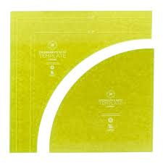
And, for fun, add a twist of lime to the face of your quilt! The Drunkard's Path is a traditional block that features curved piecing. We look forward to seeing your interpretation of the Drunkard's Path block in this challenge!
Rules:
1. All entries must include multiple Drunkard's Path units.
2. All entries must use the color lime green. The color lime is to be easily identified on the front face of the quilt.
3. All entries are to measure 24" square.
4. No clothing, bags, or accessories. Quilt is to be completed, quilted, and bound. Quilt must have a top, batting, back, quilting and completed binding.
5. Only the front of the quilt will be displayed for voting.
6. One entry per member.
7. If using a designer pattern, please credit your source.
8. Have fun! Questions? Contact Catherine Morano, Jody Bitzel, or Maureen Sopko

